-----------------------------------------------------------------------------------
Assignment 4: Create Stored procedure in Northwind database to insert or update a record in a table
-----------------------------------------------------------------------------------
create database Northwind_new

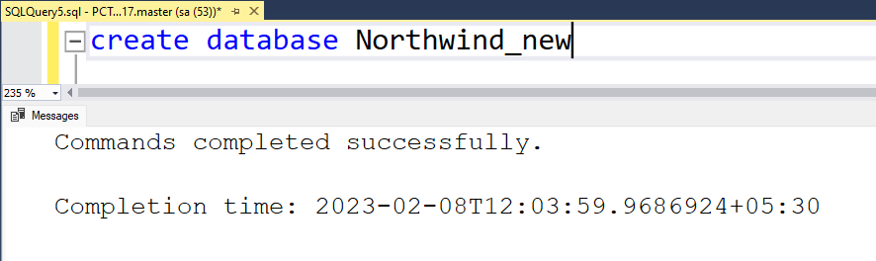

CREATE TABLE categories (
category_id int NOT NULL PRIMARY KEY,
category_name nvarchar(15) NOT NULL,
[description] text,
picture image
);

CREATE TABLE customers (
customer_id char(5) NOT NULL PRIMARY KEY,
company_name nvarchar(40) NOT NULL,
contact_name nvarchar(30),
contact_title nvarchar(30),
[address] nvarchar(60),
city nvarchar(15),
region nvarchar(15),
postal_code nvarchar(10),
country nvarchar(15),
phone nvarchar(24),
fax nvarchar(24)
);

CREATE TABLE employees (
employee_id int NOT NULL PRIMARY KEY,
last_name nvarchar(20) NOT NULL,
first_name nvarchar(10) NOT NULL,
title nvarchar(30),
title_of_courtesy nvarchar(25),
birth_date date,
hire_date date,
[address] nvarchar(60),
city nvarchar(15),
region nvarchar(15),
postal_code nvarchar(10),
country nvarchar(15),
home_phone nvarchar(24),
extension nvarchar(4),
photo image,
notes text,
reports_to int,
photo_path nvarchar(255),
FOREIGN KEY (reports_to) REFERENCES employees (employee_id)
);

CREATE TABLE suppliers (
supplier_id int NOT NULL PRIMARY KEY,
company_name nvarchar(40) NOT NULL,
contact_name nvarchar(30),
contact_title nvarchar(30),
[address] nvarchar(60),
city nvarchar(15),
region nvarchar(15),
postal_code nvarchar(10),
country nvarchar(15),
phone nvarchar(24),
fax nvarchar(24),
homepage text
);

CREATE TABLE products (
product_id int NOT NULL PRIMARY KEY,
product_name nvarchar(40) NOT NULL,
supplier_id int,
category_id int,
quantity_per_unit nvarchar(20),
unit_price real,
units_in_stock int,
units_on_order int,
reorder_level int,
discontinued bit NOT NULL,
FOREIGN KEY (category_id) REFERENCES categories(category_id),
FOREIGN KEY (supplier_id) REFERENCES suppliers(supplier_id)
);

CREATE TABLE shippers (
shipper_id int NOT NULL PRIMARY KEY,
company_name nvarchar(40) NOT NULL,
phone nvarchar(24)
);

CREATE TABLE orders (
order_id int NOT NULL PRIMARY KEY,
customer_id char(5),
employee_id int,
order_date date,
required_date date,
shipped_date date,
ship_via int,
freight real,
ship_name nvarchar(40),
ship_address nvarchar(60),
ship_city nvarchar(15),
ship_region nvarchar(15),
ship_postal_code nvarchar(10),
ship_country nvarchar(15),
FOREIGN KEY (customer_id) REFERENCES customers,
FOREIGN KEY (employee_id) REFERENCES employees,
FOREIGN KEY (ship_via) REFERENCES shippers
);

CREATE TABLE order_details (
order_id int NOT NULL,
product_id int NOT NULL,
unit_price real NOT NULL,
quantity int NOT NULL,
discount real NOT NULL,
PRIMARY KEY (order_id, product_id),
FOREIGN KEY (product_id) REFERENCES products,
FOREIGN KEY (order_id) REFERENCES orders
);

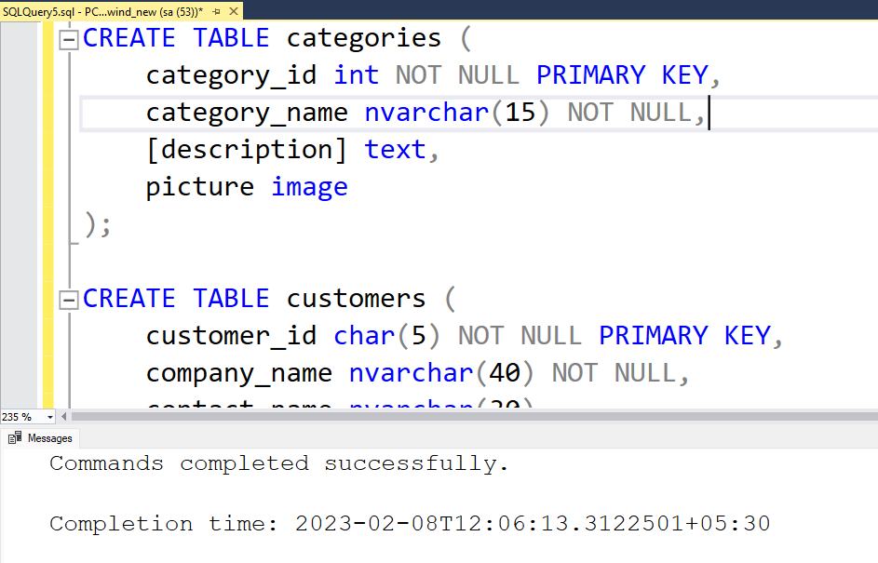
1. Create a stored procedure in the Northwind database that will calculate the average value of Freight for a specified customer.Then, a business rule will be added that will be triggered before every Update and Insert command in the Orders controller,and will use the stored procedure to verify that the Freight does not exceed the average
freight. If it does, a message will be displayed and the command will be cancelled.

-- Que 1

create procedure sp_AvgFreightByID
-- inputted customer
@CustomerID nvarchar(5),
-- returned average freight
@AverageFreight money output
as
begin
select @AverageFreight = AVG(Freight)
from Orders
where customer_id = @CustomerID
end
go

CREATE TRIGGER tr_Orders_ForInsertUpdate
ON orders
FOR INSERT, UPDATE
AS
BEGIN
DECLARE @AverageFreightValue real, @InsertedFreight real
DECLARE @CustomerId char(5)
DECLARE @errorText NVARCHAR(100)
SELECT
@CustomerId = customer_id,
@InsertedFreight = freight
FROM inserted

EXECUTE sp_AvgFreightByID @CustomerId , @AverageFreight = @AverageFreightValue OUTPUT

IF @InsertedFreight > @AverageFreightValue
BEGIN
SET @errorText = 'Frieght Value cannot be greater than Average Fright value = '+CAST(@AverageFreightValue AS NVARCHAR)
RAISERROR(@errorText,16,1)
ROLLBACK TRAN
END

END

INSERT INTO orders VALUES
(10, 'VINET', 5, '1996-07-04', '1996-08-01', '1996-07-16', 3, 32.38, 'Vins et alcools Chevalier', '59 rue de l''Abbaye', 'Reims', NULL, '51100', 'France');

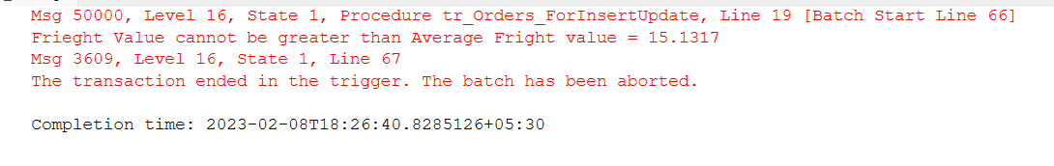

UPDATE Orders
SET freight = 200
WHERE order_id = 10248;

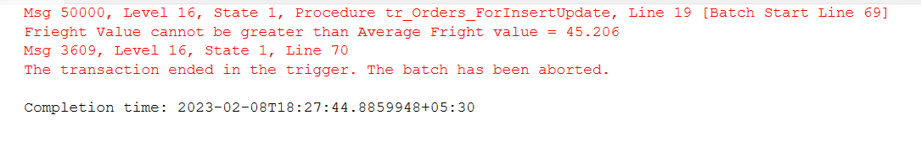

2. write a SQL query to Create Stored procedure in the Northwind database to retrieve Employee Sales by Country

create procedure spEmpSalesByCountry
@country varchar(50)
as
select e.first_name, e.last_name, count(o.customer_id) as total_sales, e.country from employees e
JOIN orders o
on e.employee_id = o.employee_id
where e.country = @country
group by e.country, e.first_name, e.last_name

-- Execution
execute spEmpSalesByCountry 'USA'
execute spEmpSalesByCountry 'UK'

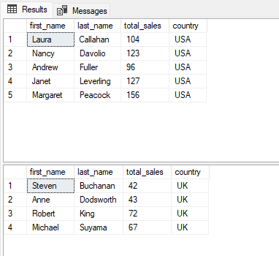
3. write a SQL query to Create Stored procedure in the Northwind database to retrieve
Sales by Year

create procedure spSalesByYear
@year varchar(4)
as
select e.first_name, e.last_name, count(o.customer_id) as total_sales,
year(o.order_date) as sales_year from employees e
join orders o
on e.employee_id = o.employee_id
where year(o.order_date) = @year
group by year(o.order_date), e.first_name, e.last_name
go

-- Execution
execute spSalesByYear '1998'
execute spSalesByYear '1996'

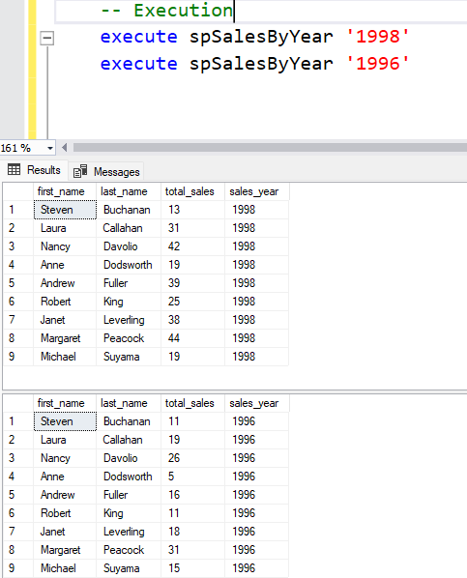
4. write a SQL query to Create Stored procedure in the Northwind database to retrieve
Sales By Category

Create procedure spSalesByCategory
@category nvarchar(50)
as
Begin
select c.category_id,c.category_name,count( od.order_id)
as total_sales
from categories c
JOIN products p on p.category_id = c.category_id
Join order_details od on p.product_id=od.product_id
where c.category_name = @category
group by c.category_id,c.category_name
End

-- Execution
execute spSalesByCategory 'Beverages'
execute spSalesByCategory 'Condiments'
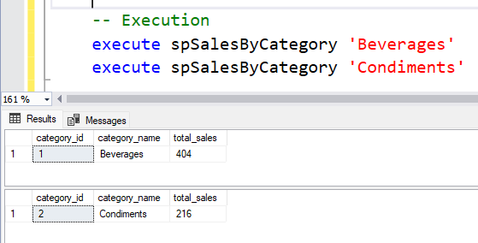

5. write a SQL query to Create Stored procedure in the Northwind database to retrieve
Ten Most Expensive Products

Create procedure sptenMostExpensiveProduct
As
Begin
Select top 10 o.product_id,p.product_name,p.unit_price
From products p
JOIN order_details o
ON p.product_id=o.product_id
group by o.product_id,p.product_name,p.unit_price
order by unit_price desc
End

-- Execution
execute sptenMostExpensiveProduct
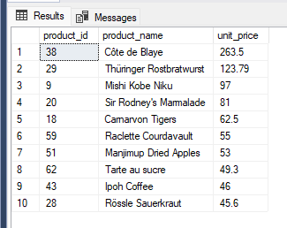

6. write a SQL query to Create Stored procedure in the Northwind database to insert
Customer Order Details

CREATE PROCEDURE spInsertCustomerOrderDetails
@CustomerId char(5), @EmployeeId int ,
@ShipVia int ,@Freight real, @ShipCountry nvarchar(15),
@ProductId int, @Quantity int, @Discount real
AS
BEGIN
DECLARE @OrderId int, @UnitPrice real
BEGIN TRAN
set @OrderId = (select max(order_id) from orders) + 1
set @UnitPrice = (select unit_price from products where product_id = @ProductId)

BEGIN TRY
INSERT INTO orders VALUES (@OrderId, @CustomerId, @EmployeeId, GETDATE(), @ShipVia, @Freight, @ShipCountry)
INSERT INTO order_details VALUES (@OrderId, @ProductId, @UnitPrice, @Quantity, @Discount)
COMMIT TRAN
END TRY
BEGIN CATCH
SELECT ERROR_MESSAGE() as Error
ROLLBACK TRAN
END CATCH
END

execute spInsertCustomerOrderDetails 120,101,12,13.5,'Spain',1001,12,5
7. write a SQL query to Create Stored procedure in the Northwind database to update
Customer Order Details

--Que 7

CREATE PROCEDURE spUpdateCustomerOrderDetails
@CustomerId char(5), @EmployeeId int ,
@ShipVia int ,@Freight real, @ShipCountry nvarchar(15),
@ProductId int, @Quantity int, @Discount real
AS
BEGIN
DECLARE @OrderId int, @UnitPrice real
BEGIN TRAN
set @OrderId = (select max(order_id) from orders) + 1
set @UnitPrice = (select unit_price from products where product_id = @ProductId)

BEGIN TRY
INSERT INTO orders VALUES (@OrderId, @CustomerId, @EmployeeId, GETDATE(), @ShipVia, @Freight, @ShipCountry)
INSERT INTO order_details VALUES (@OrderId, @ProductId, @UnitPrice, @Quantity, @Discount)
COMMIT TRAN
END TRY
BEGIN CATCH
SELECT ERROR_MESSAGE() as Error
ROLLBACK TRAN
END CATCH
END

execute spUpdateCustomerOrderDetails 120,101,12,13.5,'Spain',1001,12,5

